3rd Sunday in Advent

CHRIST LUTHERAN CHURCH | Lodi, California
December 17, 2023

WELCOME TO WORSHIP
Welcome to Christ Lutheran Church. We pray that your soul will be strengthened by the good news about God’s grace, love, and forgiveness given to us. If you would like to learn more about our church, please speak with our pastor or one of our members after the service.
- Bathrooms are located in the fellowship hall. A changing table is located in the women’s bathroom.
WORSHIP THEME
The Lord sends his witnesses. They come to prepare us with their preaching, so that we can be ready for the Light of the World to enter our own lives. But many reject their message. May our hearts welcome the message of John the Baptist in this last week before Christmas: “Make straight the way of the Lord!”

The Service of the Word and Sacrament
The high and holy worship of God is faith in Jesus Christ. Such faith is created and sustained by God’s service to us (the German, “Gottesdienst,” “God/Divine Service). In the Divine Service, the Lord comes to us in His Word and Sacrament to bless and enliven us with His gifts. The Service is not something we do for God, but His service to us received in faith. The liturgy is God’s work. He gives, we receive.
HYMN When All the World Was Cursed| CW 20
INVOCATION
M: The grace of our Lord ✙ Jesus Christ and the love of God and the fellowship of the Holy Spirit be with you.
C: And also with you.
CONFESSION
From God’s Word we know that wherever God puts His name, there He is to bless. In the Old Testament the temple was the place where God graciously caused His name to be present (1 Kings 8:27-30).
God has put His name —Father, Son, and Holy Spirit—on us in Holy Baptism. The Divine Service begins with the Invocation, the words spoken over us at our baptisms. Every Divine Service is for the hallowing of the Lord’s name, which the Small Catechism reminds us is done “when the Word of God is taught in its truth and purity, and we, as the children of God, also lead holy lives according to it” (Matthew 28:18-20).
M: God invites us to come into his presence and worship him with humble and penitent hearts. Therefore, let us acknowledge our sinfulness and ask him to forgive us.
C: Holy and merciful Father, I confess that I am by nature sinful, and that I have disobeyed you in my thoughts, words, and actions. I have done what is evil and failed to do what is good. For this I deserve your punishment both now and in eternity. But I am truly sorry for my sins, and trusting in my Savior Jesus Christ, I pray: Lord, have mercy on me, a sinner.

absolution
M: God, our heavenly Father, has been merciful to us and has given his only Son to be the atoning sacrifice for our sins. Therefore, as a called servant of Christ and by his authority, I forgive you all your sins in the name of the Father and of the Son ✙ and of the Holy Spirit.
C: Amen
LORD, HAVE MERCY - Kyrie
M: For all that we need in life and for the wisdom to use all your gifts with gratitude and joy, hear our prayer, O Lord.
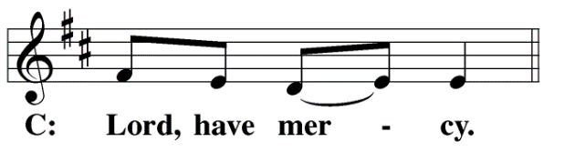
M: For the steadfast assurance that nothing can separate us from your love and for the courage to stand firm against the assaults of Satan and every evil, hear our prayer, O Christ.
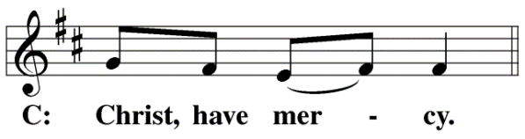

M: For the well-being of your holy Church in all the world and for those who offer here their worship and praise, hear our prayer, O Lord.
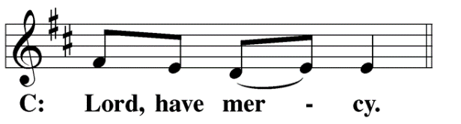
M: Merciful God, maker and preserver of life, uphold us by your power and keep us in your tender care:
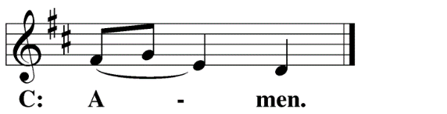
M: The works of the Lord are great and glorious; his name is worthy of praise.
O LORD, OUR LORD
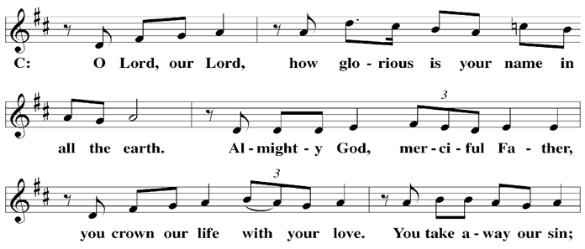

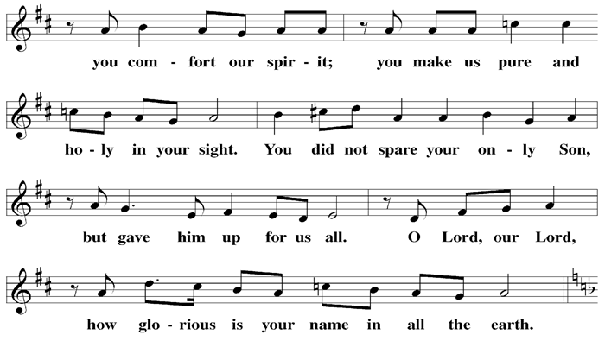

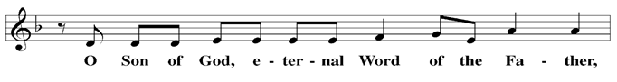

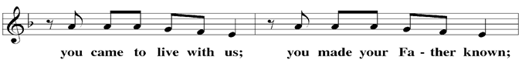

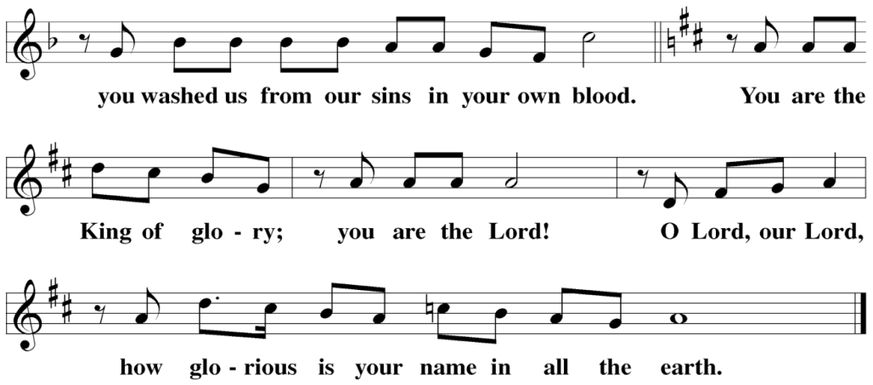

The Service of the Word
Having just received absolution for their sins, believers now gather around the Word of God to find encouragement and peace for their lives on earth.
PRAYER OF THE DAY
M: Let us pray.
Hear our prayers, Lord Jesus Christ, and come with the good news of your mighty deliverance. Drive the darkness from our hearts and fill us with your light; for you live and reign with the Father and the Holy Spirit, one God, now and forever.
C: Amen
FIRST LESSON Isaiah 61:1–3,10,11
The Lord comes and he changes everything: those who once suffered now have comfort, and those who sinned find salvation.
61 The Spirit of the Sovereign Lord is on me,
because the Lord has anointed me
to proclaim good news to the poor.
He has sent me to bind up the brokenhearted,
to proclaim freedom for the captives
and release from darkness for the prisoners,
² to proclaim the year of the Lord’s favor
and the day of vengeance of our God,
to comfort all who mourn,
³ and provide for those who grieve in Zion—
to bestow on them a crown of beauty
instead of ashes,
the oil of joy
instead of mourning,
and a garment of praise
instead of a spirit of despair.
They will be called oaks of righteousness,
a planting of the Lord
for the display of his splendor.
¹⁰ I delight greatly in the Lord;
my soul rejoices in my God.
For he has clothed me with garments of salvation
and arrayed me in a robe of his righteousness,
as a bridegroom adorns his head like a priest,
and as a bride adorns herself with her jewels.
¹¹ For as the soil makes the sprout come up
and a garden causes seeds to grow,
so the Sovereign Lord will make righteousness
and praise spring up before all nations.
PSALM Psalm 71, Blue Hymnal
SECOND LESSON 1 Thessalonians 5:16–24
How will we live in these last days, while we wait for our Lord to return? Not in fear and doubt, but in lives of joy and holiness.
¹⁶ Rejoice always, ¹⁷ pray continually, ¹⁸ give thanks in all circumstances; for this is God’s will for you in Christ Jesus.
¹⁹ Do not quench the Spirit. ²⁰ Do not treat prophecies with contempt ²¹ but test them all; hold on to what is good, ²² reject every kind of evil.
²³ May God himself, the God of peace, sanctify you through and through. May your whole spirit, soul and body be kept blameless at the coming of our Lord Jesus Christ. ²⁴ The one who calls you is faithful, and he will do it.
VERSE OF THE DAY Matthew 11:10
Alleluia. I will send my messenger ahead of you, who will prepare your way before you. Alleluia.
THE GOSPEL John 1:6–8,19–28
The people rejected John because they took offense at him; all the while, they missed the Light of the World that John came to point them to.
⁶ There was a man sent from God whose name was John. ⁷ He came as a witness to testify concerning that light, so that through him all might believe. ⁸ He himself was not the light; he came only as a witness to the light.

¹⁹ Now this was John’s testimony when the Jewish leaders in Jerusalem sent priests and Levites to ask him who he was. ²⁰ He did not fail to confess, but confessed freely, “I am not the Messiah.”
²¹ They asked him, “Then who are you? Are you Elijah?”
He said, “I am not.”
“Are you the Prophet?”
He answered, “No.”
²² Finally they said, “Who are you? Give us an answer to take back to those who sent us. What do you say about yourself?”
²³ John replied in the words of Isaiah the prophet, “I am the voice of one calling in the wilderness, ‘Make straight the way for the Lord.’”
²⁴ Now the Pharisees who had been sent ²⁵ questioned him, “Why then do you baptize if you are not the Messiah, nor Elijah, nor the Prophet?”
²⁶ “I baptize with water,” John replied, “but among you stands one you do not know. ²⁷ He is the one who comes after me, the straps of whose sandals I am not worthy to untie.”
²⁸ This all happened at Bethany on the other side of the Jordan, where John was baptizing.

M: This is the Gospel of the Lord.
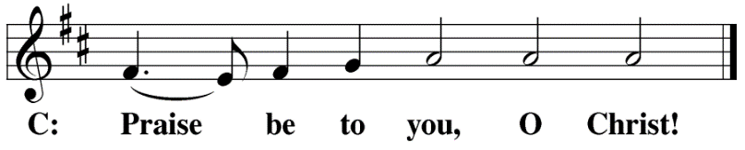

HYMN OF THE DAY Arise, O Christian People| CW 14
SERMON 1 Thessalonians 5
NICENE CREED
Having heard the Word of God, we confess our faith in His name. The creed is our saying back to God what He has first said to us. In the Creed we acclaim the truth of the triune God and His work of salvation accomplished for us in His incarnate Son, Jesus Christ.
We believe in one God, Dt. 6:4
the Father, the Almighty, 2 Cor. 6:18
maker of heaven and earth, Is. 51:13
of all that is, seen and unseen. Col. 1:16
We believe in one Lord, Jesus Christ, 1 Cor 8:6
The Nicene Creed is the great Confession of the Christian faith professed by all Christians. The Creed originated at the First Council of Nicaea (c. AD. 325)
the only Son of God, Jn. 3:16
eternally begotten of the Father, Heb. 1:2,5
God from God, Light from Light, true God from true God, Jn. 1
begotten, not made, of one being with the Father. Jn. 10:30
Through him all things were made. Jn. 1:3
For us and for our salvation, 1 Th. 5:9
he came down from heaven, Jn. 6:38
was incarnate of the Holy Spirit and the virgin Mary, Lk. 1:35
and became fully human. Gal. 4:4
For our sake he was crucified under Pontius Pilate. Mk. 15:15
The Creed itself was crafted as a confession of Scripture in opposition to the Arian heresy, which denied that the Lord Jesus and the Holy Spirit are God.

He suffered death and was buried. 1 Cor. 15:3-4a
On the third day he rose again in accordance
with the Scriptures. 1 Cor. 15:4b
He ascended into heaven Ac. 2:33-34
and is seated at the right hand of the Father. Heb. 1:13
He will come again in glory Mt. 25:31
to judge the living and the dead, 2 Tim. 4:1
and his kingdom will have no end. Lk. 1:33
We believe in the Holy Spirit, the Lord, the giver of life, Job 33:4
who proceeds from the Father and the Son, Jn. 15:26
who in unity with the Father and the Son Jn. 4:24
is worshiped and glorified,
who has spoken through the prophets. 2 Pet. 1:25
We believe in one holy Christian Mt. 16:18; Eph. 2:19-20
and apostolic Church.
We acknowledge one baptism for the forgiveness of sins. Eph. 4:5; Ac. 2:38
We look for the resurrection of the dead 1 Cor. 15:21-22
and the life of the world to come. Amen. Rev. 22

OFFERING
In response to God’s love and forgiveness, we give back a portion of what he has given us. The members of Christ Lutheran Church have joined to proclaim the gospel to this community. These offerings support that work. While our guests are welcome to participate, they should not feel obligated to do so.
PRAYER OF THE CHURCH
M: Almighty God, You sent John the Baptist to proclaim the baptism of repentance for the forgiveness of sins. Grant that we who prepare to celebrate the incarnation of our Lord Jesus Christ may die to sin and rise to new life.
C: May we treasure up and ponder in our hearts the Christ announced by Your forerunner.
M: You sent John to proclaim the Lamb of God that takes away the sin of the world. Richly and daily forgive our sins and the sins of all believers. Bless your servants Mark, our Synod president; John, our district president; Dave, our circuit pastor; and all shepherds of your flock in Christ. Gather and preserve Your Holy Christian Church by Your voice.
C: Send us faithful preachers who will not deny but confess Your truth.
M: Heavenly Father, we kneel before you, for from you every family in heaven and on earth receives its name. Bless the children of our families, that every darkness would be lightened by Your Son’s gracious visitation. Preserve them from dangers to body and soul, guide them by Your Word in wise paths, and keep them firm in the faith until life’s end.
C: Be the source of strength and comfort in every home.
M: Righteous Lord, You rule over all things in heaven and on earth. Bring peace to our world through your mighty arm. May the message of peace and goodwill reign through the preaching of your gospel. Have mercy upon the people of Ukraine and Russia, Israel and Gaza. May we all long for the day when your Son comes in glory to usher in his kingdom.
C: Give wisdom and insight to all leaders, that we may live peaceable lives.
M: Creator of all, many in our midst have been afflicted with pain, sickness, trials and difficulties. Be merciful to those who are close to us,
Specific intercessions may be inserted
May all these be granted health or strength to endure their afflictions. Help us all to see that when Christ returns in glory, our bodies will be incorruptible and immortal when He makes all things new.
C: Prepare our souls for the restoration of our bodies.

M: Heavenly Father, Your Church eagerly awaits the return of her Bridegroom. Grant that we would not grow weary. Strengthen us through Your Word and Sacraments. Through your grace, make us worthy recipients of your Son’s body and blood—the foretaste of his heavenly banquet.
C: May we ever hold fast Your promise of salvation won for us by Christ.
M: O Lord, heavenly Father, we gratefully remember the sufferings and death of Your dear Son, Jesus Christ, for our salvation. Rejoicing in His victorious resurrection from the dead, we draw strength from His ascension before You, where He ever stands for us as our own High Priest. Gather us together from the ends of the earth to celebrate with all the faithful the marriage feast of the Lamb in His kingdom, which has no end. Graciously receive our prayers, deliver and preserve us, for to You alone we give all glory, honor and worship, Father, Son and Holy Spirit, one God, now and forever.
C: Amen.
LORD’S PRAYER Matthew 6:9-13; Luke 11:2-4
C: Our Father, who art in heaven, hallowed be thy name,
thy kingdom come, thy will be done on earth as it is in heaven.
Give us this day our daily bread;
and forgive us our trespasses, as we forgive those
who trespass against us;
and lead us not into temptation, but deliver us from evil.
For thine is the kingdom and the power
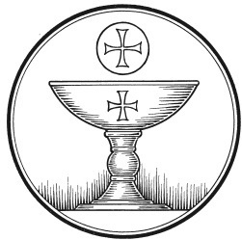
and the glory forever and ever. Amen.

The Service of the Sacrament
This greeting marks a new service, so to speak. These ancient introductory words & phrases help to highlight, celebrate and bring attention to the Sacrament.
M: The Lord be with you.
C: And also with you.
M: Lift up your hearts.
C: We lift them up to the Lord.
M: Let us give thanks to the Lord our God.
C: It is right to give him thanks and praise.
M: Praise to the God and Father of our Lord Jesus Christ! In love he has blessed us with every spiritual blessing. Through his holy prophets, he promised a King to bring light to those living in darkness and in the shadow of death. Now have come the salvation and the power and the kingdom of our God and the authority of his Christ. To him who sits on the throne and to the Lamb be praise and thanks and honor and glory for ever and ever:

HOLY, HOLY, HOLY – Sanctus
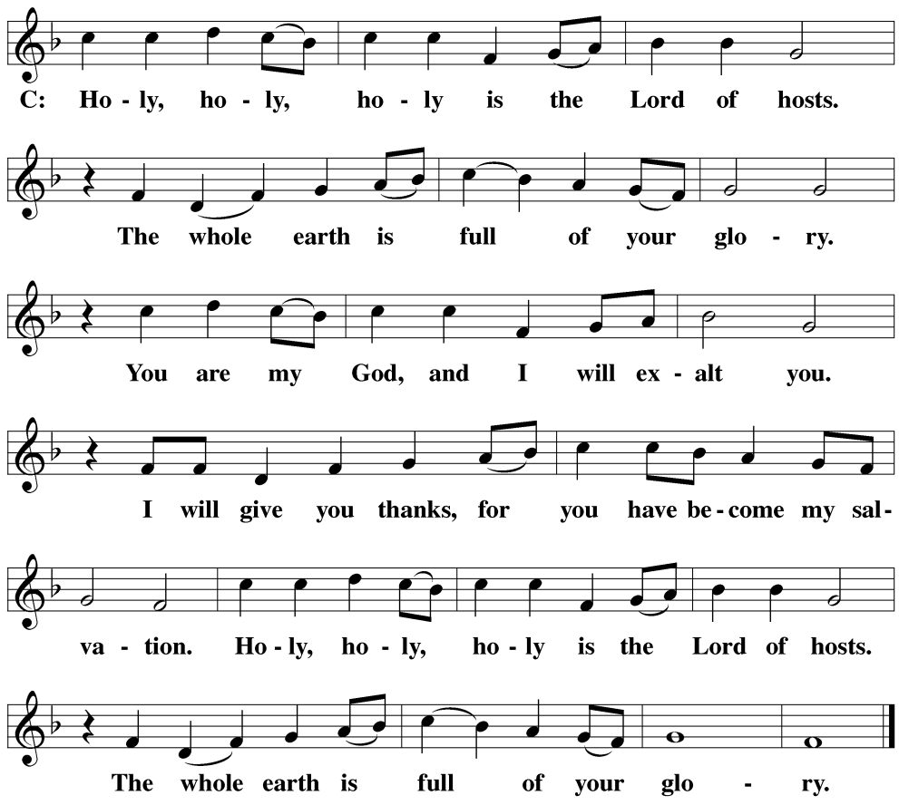

WORDS OF INSTITUTION Matthew 26, Mark 14, Luke 22
M: Our Lord Jesus Christ, on the night he was betrayed, took bread; and when he had given thanks, he broke it and gave it to his disciples, saying: “Take and eat. This is my ✙ body, which is given for you. Do this in remembrance of me.”
The Words of institution both proclaim the words of Jesus to the congregation and sets apart the bread and wine for the Lord’s Supper.
Then he took the cup, gave thanks, and gave it to them, saying, “Drink from it all of you; this is my ✙ blood of the new covenant, which is poured out for you for the forgiveness of sins. Do this, whenever you drink it, in remembrance of me.”
PEACE OF THE LORD – Pax Domini John 20:19
M: The peace of the Lord be with you always.
C: Amen
O CHRIST, LAMB OF GOD – Agnus Dei John 1:29
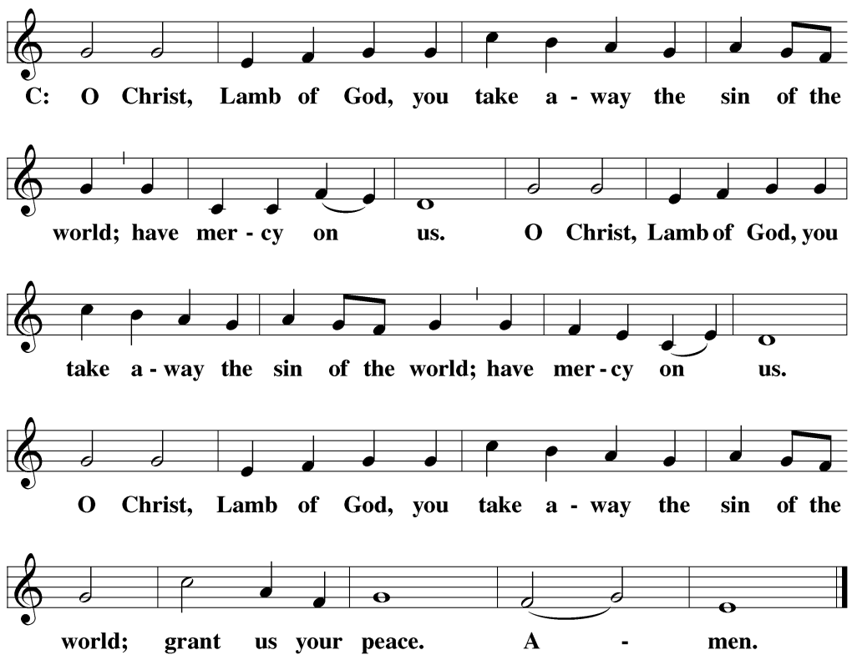

DISTRIBUTION
Those who will be receiving Holy Communion today may wish to read Personal Preparation for Holy Communion, found on page 156 in the front section of the hymnal. This page helps us put into practice what the Bible encourages: “Everyone ought to examine themselves before they eat of the bread and drink from the cup.” (1 Corinthians 11:28)
Christ Lutheran Church confesses and practices the Biblical teaching of a Closed Communion. We ask that only members of the Wisconsin Synod [WELS] or the Evangelical Lutheran Synod [ELS] join us at the Lord’s Table. If you have questions concerning our communion practice, or would like to inquire about how you, too, can commune with us, please speak with the Pastor following the service.

THANK THE LORD
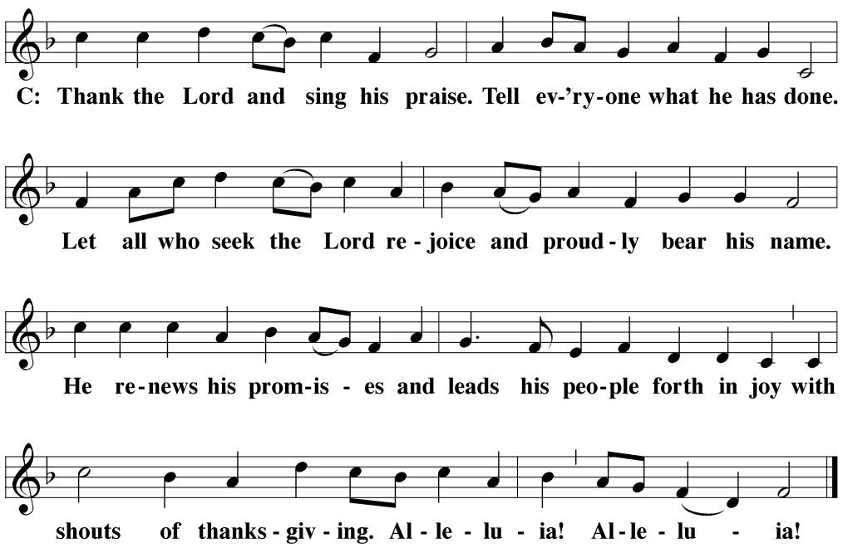

M: Hear the prayer of your people, O Lord, that the lips which have praised you here may glorify you in the world, that the eyes which have seen the coming of your Son may long for his coming again, and that all who have received in his true body and blood the pledge of your forgiveness may be restored to live a new and holy life, through Jesus Christ, our Lord, who lives and reigns with you and the Holy Spirit, one God, now and forever.
C: Amen.
THE BLESSING
M: Brothers and sisters, go in peace. Live in harmony with one another. Serve the Lord with gladness.
The Lord bless you and keep you.
The Lord make his face shine on you and be gracious to you.
The Lord look on you with favor and ✙ give you peace.
C: Amen.
CLOSING HYMN O Lord, How Shall I Meet You | CW 18

COPYRIGHT INFORMATION
Content requiring a copyright license is reproduced under OneLicense.net #A-718312. All rights reserved. The Common Service: Texts revised from The Lutheran Hymnal, 1941. Music revised by James Engel. Scripture Quotations: From the Holy Bible, New International Version (NIV 1984), © 1973, 1978, 1984 by Biblica, Inc.

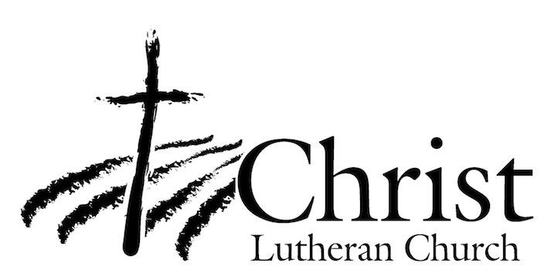
13009 N. Elderberry Ct.
Lodi, CA 95242
www.christlodi.org
209-368-6250
Pastor Timothy Leistekow
WELCOME TO CHRIST EV. LUTHERAN CHURCH!
We preach a message of forgiveness, hope and peace
through the death and resurrection of Jesus Christ.
Families and individuals of all ages will find opportunities
both to grow and to serve.
Our mission statement:
Look what Christ is doing!
He binds us together in fellowship
He gathers us in for worship
He builds us up for service
He sends us out with the gospel

“Now you are the body of Christ,
and each one of you is a part of it.”
(1 Corinthians 12:27)

